**Test Report No.:** NGBHL23003418801 **Date:** Aug 07, 2023 Page 1 of 4 Client Name: CHEMNOVO NEW MATERIALS TECHNOLOGY (ZHEJIANG) CO.,LTD.

Client Address: NO.8,SITONG AVENUE ,HUIBU TOWN ,CHANGSHAN COUNTY,QUZHOU

Sample Description: PE WAX

Manufacturer: CHEMNOVO NEW MATERIALS TECHNOLOGY (ZHEJIANG) CO.,LTD. Supplier: CHEMNOVO NEW MATERIALS TECHNOLOGY (ZHEJIANG) CO.,LTD.

The above sample(s) and information were provided by the client.

SGS No.: NBHL2307014267OT

Sample Receiving Date: Aug 01, 2023

Testing Period: Aug 01, 2023 ~ Aug 07, 2023

Test Requested: Select test(s) as requested by the client. Testing Performed: Follow selected test(s) as requested by client.

|  |  |  |
| --- | --- | --- |
|  | **Test Requirement** | **Conclusion** |
| 1 | Elemental analysis, Hexavalent Chromium(Cr(VI)), Flame Retardants & Phthalates | See Results |
| 2 | Total Lead, Cadmium, Mercury and Hexavalent Chromium content | See Results |

Signed for and on behalf of

SGS-CSTC Standards Technical Services Co., Ltd. Ningbo Branch

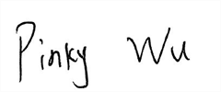

Pinky Wu Approved Signatory

**Test Report No.:** NGBHL23003418801 **Date:** Aug 07, 2023 Page 2 of 4

# Test Result(s):

Test Part Description：

# SN ID Sample No. SGS Sample ID Description

SN1 A1 NGB23-0034188-0001.C001 White powder

Remarks:

1. 1 mg/kg = 1 ppm = 0.0001%
2. MDL = Method Detection Limit
3. ND = Not Detected (< MDL)
4. “-“ = Not Regulated

# Elemental analysis, Hexavalent Chromium(Cr(VI)), Flame Retardants & Phthalates

Test Method: With reference to IEC 62321-4:2013+AMD1:2017, IEC 62321-5:2013, IEC 62321-7-2:2017,

IEC 62321-6:2015 and IEC 62321-8:2017, analysis was performed by ICP-OES, UV-Vis and GC-MS.

|  |  |  |  |
| --- | --- | --- | --- |
| Test Item(s) | Unit(s) | MDL | *A1* |
| Cadmium(Cd) | mg/kg | 2 | ND |
| Lead (Pb) | mg/kg | 2 | ND |
| Mercury (Hg) | mg/kg | 2 | ND |
| Hexavalent Chromium (Cr(VI)) | mg/kg | 8 | ND |
| Polybromobiphenyl (PBBs) | mg/kg | - | ND |
| Monobromobiphenyl (MonoBB) | mg/kg | 5 | ND |
| Dibromobiphenyl (DiBB) | mg/kg | 5 | ND |
| Tribromobiphenyl (TriBB) | mg/kg | 5 | ND |
| Tetrabromobiphenyl (TetraBB) | mg/kg | 5 | ND |
| Pentabromobiphenyl (PentaBB) | mg/kg | 5 | ND |
| Hexabromobiphenyl (HexaBB) | mg/kg | 5 | ND |
| Heptabromobiphenyl (HeptaBB) | mg/kg | 5 | ND |
| Octabromobiphenyl (OctaBB) | mg/kg | 5 | ND |
| Nonabromobiphenyl (NonaBB) | mg/kg | 5 | ND |
| Decabromobiphenyl (DecaBB) | mg/kg | 5 | ND |
| Polybromodiphenyl ether(PBDEs) | mg/kg | - | ND |
| Monobromodiphenylether (MonoBDE) | mg/kg | 5 | ND |
| Dibromodiphenylether (DiBDE) | mg/kg | 5 | ND |
| Tribromodiphenylether (TriBDE) | mg/kg | 5 | ND |
| Tetrabromodiphenylether (TetraBDE) | mg/kg | 5 | ND |
| Pentabromodiphenylether (PentaBDE) | mg/kg | 5 | ND |
| Hexabromodiphenylether (HexaBDE) | mg/kg | 5 | ND |
| Heptabromodiphenylether (HeptaBDE) | mg/kg | 5 | ND |
| Octabromodiphenylether (OctaBDE) | mg/kg | 5 | ND |
| Nonabromodiphenylether (NonaBDE) | mg/kg | 5 | ND |
| Decabromodiphenylether (DecaBDE) | mg/kg | 5 | ND |
| Dibutyl Phthalate(DBP) | mg/kg | 50 | ND |
| Benzyl Butyl Phthalate(BBP) | mg/kg | 50 | ND |
| Bis-(2-ethylhexyl) Phthalate(DEHP) | mg/kg | 50 | ND |
| Diisobutyl Phthalate(DIBP) | mg/kg | 50 | ND |

**Test Report No.:** NGBHL23003418801 **Date:** Aug 07, 2023 Page 3 of 4

# Total Lead, Cadmium, Mercury and Hexavalent Chromium content

Test Method: With reference to SGS in house method, analysis were performed by ICP-OES/AAS, UV- Vis.

|  |  |  |  |
| --- | --- | --- | --- |
| Test Item(s) | Unit(s) | MDL | *A1* |
| Cadmium(Cd) | mg/kg | 5 | ND |
| Lead(Pb) | mg/kg | 5 | ND |
| Mercury(Hg) | mg/kg | 5 | ND |
| Hexavalent Chromium(CrVI) | mg/kg | 8 | ND |
| Total (Cd+ Pb + Hg + CrVI) | mg/kg | - | ND |

Unless otherwise stated, the decision rule for conformity reporting is based on Binary Statement for Simple Acceptance Rule (*w*=0) stated in ILAC-G8:09/2019.

**Test Report No.:** NGBHL23003418801 **Date:** Aug 07, 2023 Page 4 of 4

# Sample Photo:

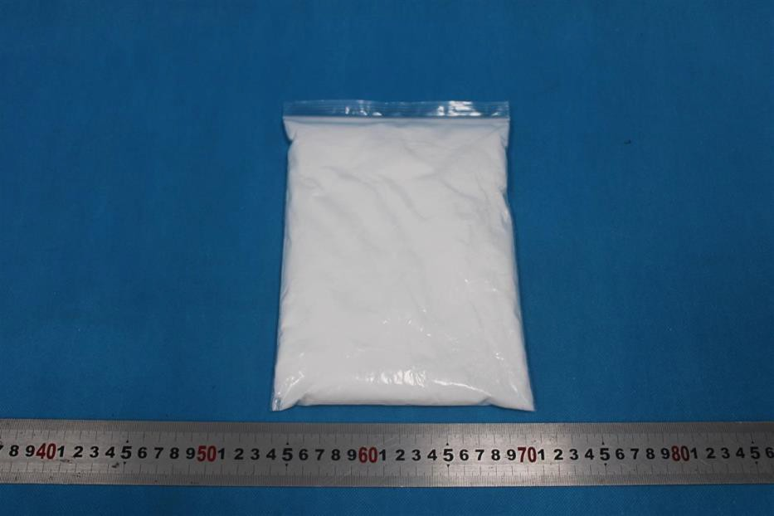

NGB23-0034188-0001.C001

SGS authenticate the photo on original report only

*** End of Report ***